Module 13

Soln- There are multiple ways by which we can select k values , but the best one is scree plot. I ran scree plot command multiple times and everytime it suggested me to take 4 or 5 as k value but I will go for 5 because getting better clustering ratio at 5.

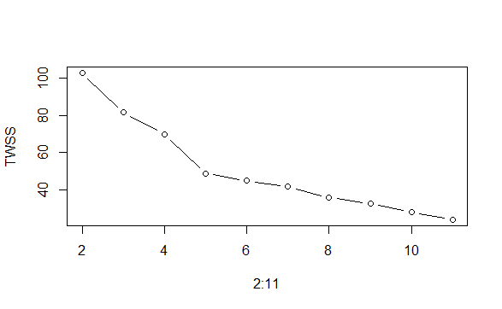
With k=5 , I will run kmeans command multiple times to get best value of clustering ratio
Totss-196, tot.withinss-49, betweenss-147. This is the best value I am getting
So my clustering ratio is 147/196= 0.75

